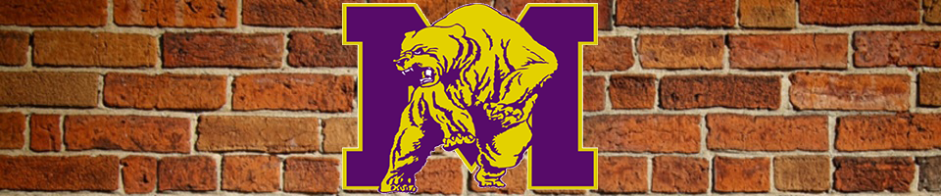  IT’S A NEW DAY AT MILES!  September 28, 2019 – February 17, 2020  ALUMNI PLAZA  Brick Pavers and More  Alumni and friends of Miles College can now leave a new permanent marker on the “Illustrious Campus” that was founded in 1898. Alumni Plaza features custom brick pavers, pots, iron benches, stone seating, bronze numbers, the Miles “M,” and the grandest contribution – the Miles Bell Tower with the ‘original bell’ dating back to 1906! These markers offer the perfect opportunity to honor those who have made the difference at the College. From September 28, 2019 until February 17, 2020 you can purchase a plethora of different items.  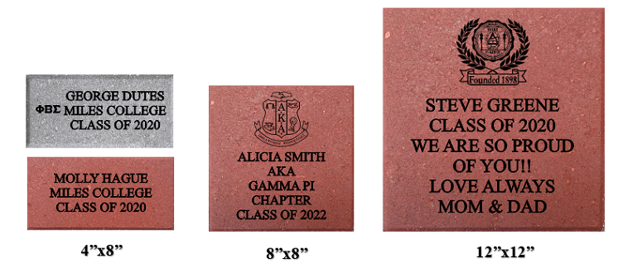 | 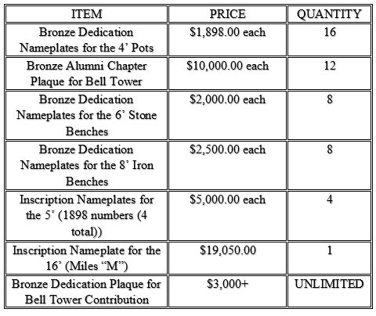  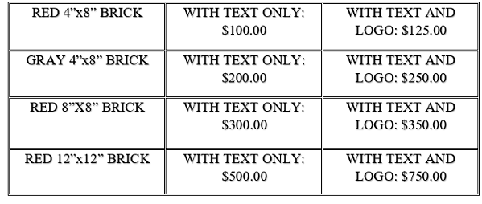

Donor Information  Name: _____________________________________  Address: _____________________________________  City, State: _________________ Zip code: __________  Email Address: ________________________________  Phone Number: (___)____________________________  Clip Art # ____________________________________  Donation Amount: $ ____________________________  Clip Art Selection  AKA1 AKA2 ALPHA1 ALPHA2 DST1  DST2 KAPSI1 KAPSI2 KKPSI1 KKPS12  MILES OMEGA1 OMEGA2 PHIBS1 PHIBS2  SIGMAG1 SIGMAGR2 TBS1 ZPHIB1 ZPHIB2  To order online and for more Clip Art choices please visit: www.polarengraving.com/MilesCollege | Please Make Checks Payable To:  Miles College  Mail To:  Miles College  Office of Institutional Advancement  5500 Myron Massey Blvd Box 98  Fairfield, Alabama 35064  Brick Information  If ordering a brick paver with ‘Clip Art,’ please do not write in the shaded areas.  4” x 8” engraved brick with Clip Art or Logo $150.00  8” x 8” engraved brick with Clip Art or Logo $250.00  12” x 12” engraved brick with Clip Art or Logo $500.00

